# **REQUIREMENT 8 – DATA GENERATION**

*27/08/2024*

# **Information:**

* **Group 13:** 21127235 – Nguyễn Xuân Quỳnh Chi

# **Tools used:**

* Data generation tool: Mockaroo (<https://www.mockaroo.com/>)

# **Process:**

* 1. **Generate 30 users:**
  + Set up:

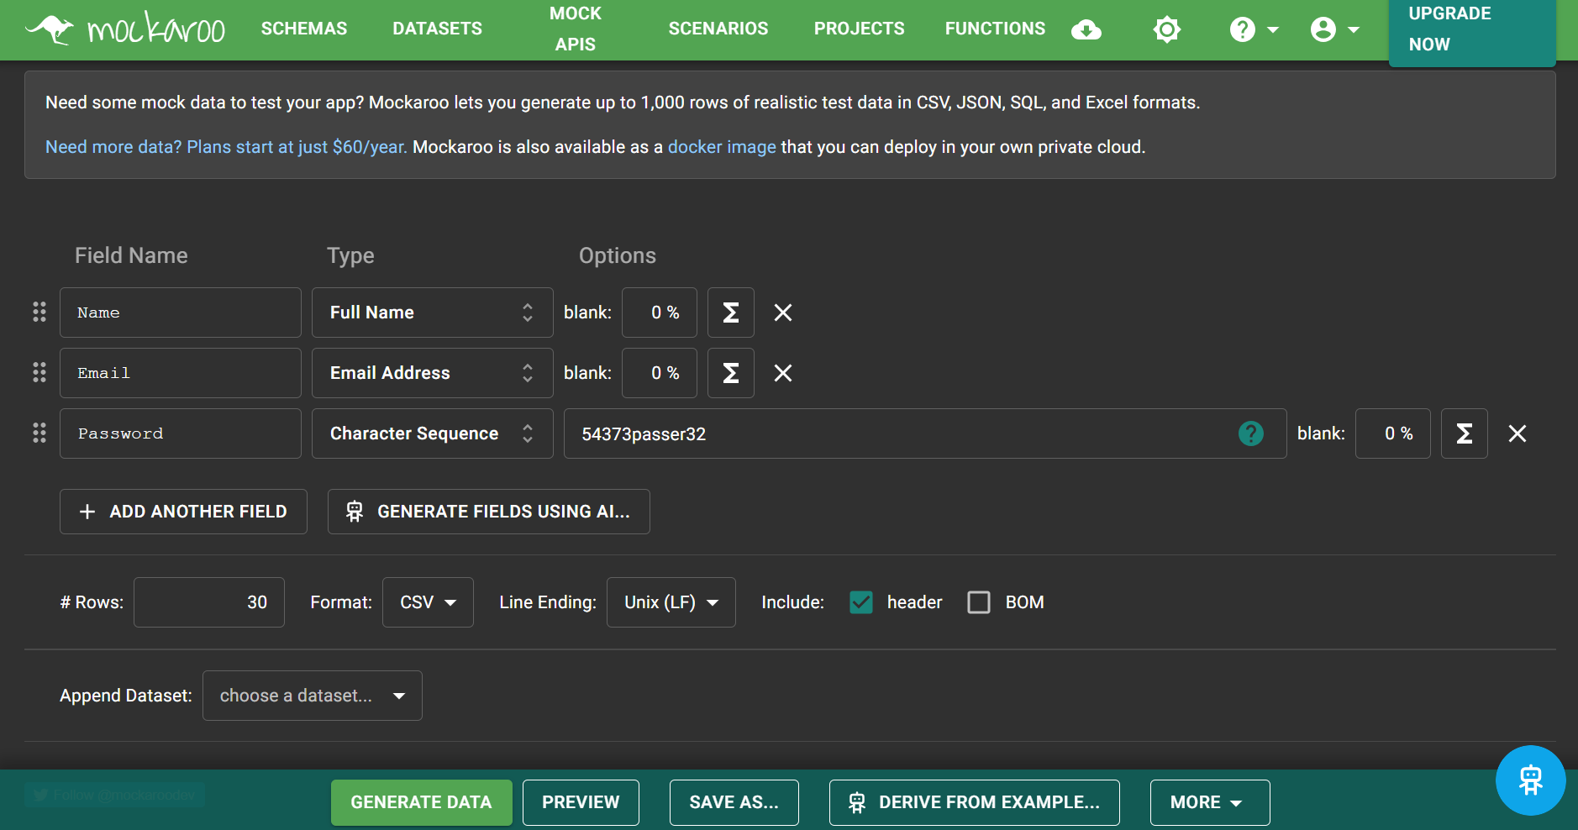

* + Data:

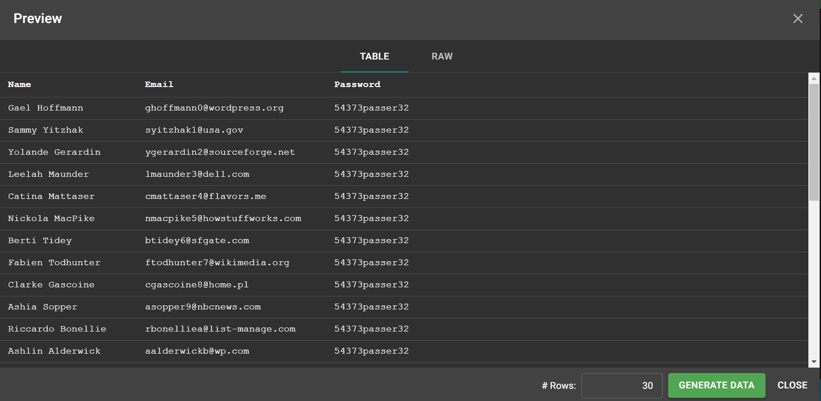

* 1. **Generate 300 issues:**
  + Set up:

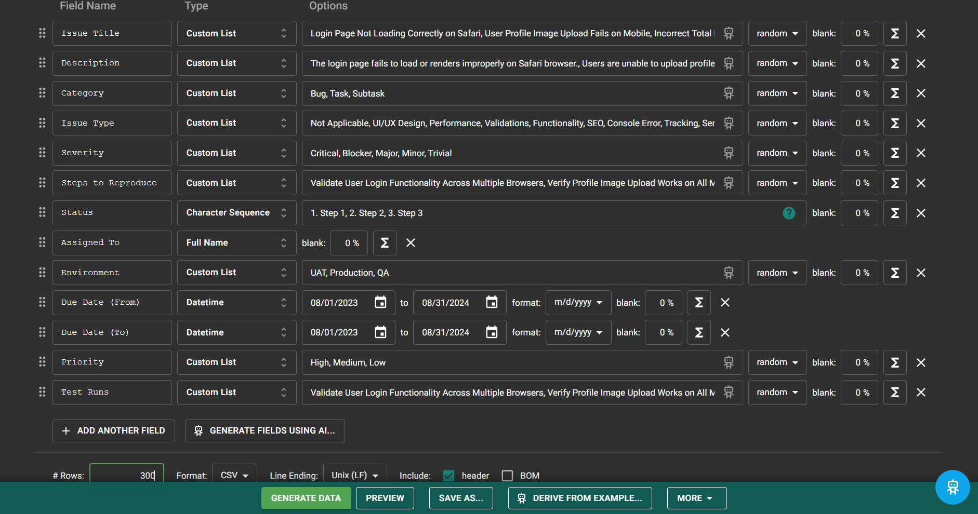

* + Data:

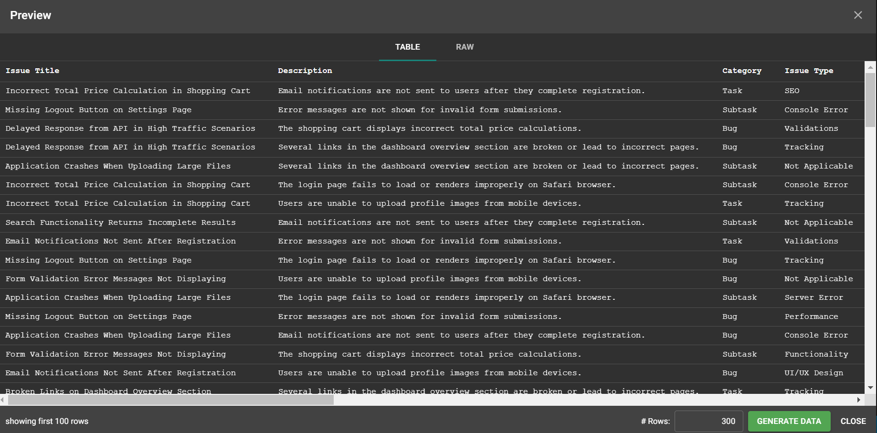

* 1. **Generate 10 projects:**
  + Set up:

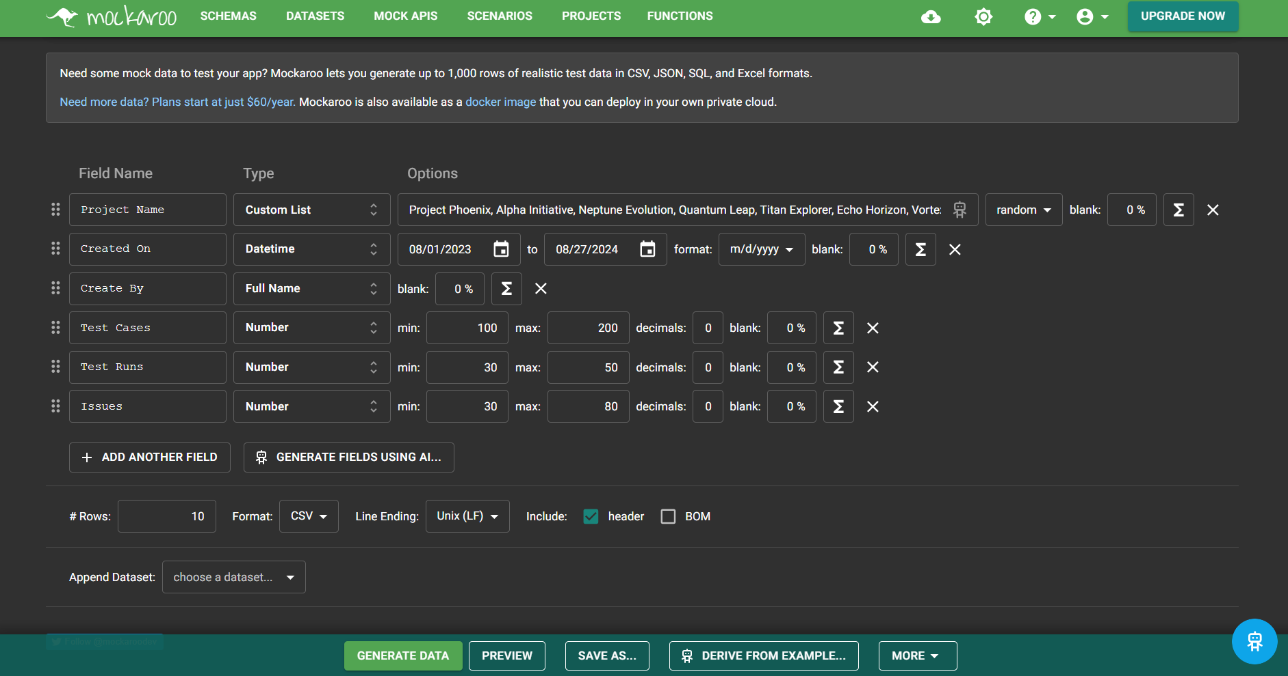

* + Data:

